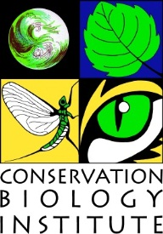
Sesha Atkuru
Conservation Biology Institute
136 SW Washington Ave., Suite 202
Corvallis, OR 97333

www.consbio.org
sesha.atkuru@consbio.org

EDUCATION
M.B.A (Oregon State University) Anticipated in April 2015.
M. Tech (JNTU, India) August 1999
Project Management Professional
Oracle Certified Professional

EMPLOYMENT HISTORY
- Fiserv Corvallis August 2005 to June 2014

SELECT PROJECT EXPERIENCE

Project Name — Data Basin. Data Basin is a science-based mapping and analysis platform that supports learning, research, and sustainable environmental stewardship. Managing Quality Assurance and Quality Control of Data Basin application. Leading implementation of quality assurance automation, web application security for Data Basin.

PROFESSIONAL REGISTRATIONS AND PERMITS
- Project Management Professional PMI active member
- PMI Willamette Valley Chapter member

